|  |
| --- |
| G:\General\FRONT OFFICE\School Crest\Lightning-RidgeCS_Crest1.gif |
| Student Welfare and Discipline Policy |
| Lightning Ridge Central School |
| *At Lightning Ridge Central School we create positive, safe and respectful learning environments that engage students in quality lessons celebrate success and promote lifelong learning.* |
|  |

This policy works in conjunction with:

* The Anti-Bullying Policy
* Excursion Policy
* OH&S policies and procedures
* Electronic devices policy

To be reviewed December 2017

Core Rules in NSW Government Schools

All students in NSW Government Schools are expected to:

* Attend every school day, unless they are legally excused, and be in class on time and prepared to learn.
* Maintain a neat appearance, including adhering to the requirements of the school’s uniform or dress code policy.
* Behave safely, considerately and responsibly, including when travelling to and from school.
* Show respect at all times for teachers, other school staff and helpers, including following class rules, speaking courteously and cooperating with instructions and learning activities.
* Treat one another with dignity and respect.
* Care for property belonging to themselves, the school and others.

Behaviour that infringes on the safety of others, such as harassment, bullying and illegal or anti-social behaviour of any kind, will not be tolerated.

Guiding Principles

1. **Rationale**

Lightning Ridge Central School exists to provide a first class education for all children who attend it. We have the following overriding priorities:

* Develop students who are proud and positive about learning.
* Create a caring and safe environment for all students and staff.
* Raise the level of educational achievement for all students.

1. **Aims**

The aims of Lightning Ridge Central School’s Student Welfare and Discipline Policy are:

* To promote the development of individual students, a role the school shares with the home.
* To create a positive and productive learning environment within the school.
* To foster in students a strong work ethic.

1. **Objectives**

* The integration of the *Positive Behaviour for Learning* (PBL) process.
* Provide access to specialist support services through the School’s Learning Support Team (LST).
* To act on data collected through the *SALM* database and ensure an appropriate balance between the proactive process of PBL and action taken on problem behaviours.

Responsibilities

**Students’ responsibilities include but are not limited to:**

* Applying themselves to learning.
* Behaving safely, considerately and responsibly at all times
* Attending school every day.
* Speaking courteously.
* Respecting teachers’ rights to courtesy, fairness and respect.
* Respecting other individuals and their property.
* Showing courtesy, dignity and respect to other students and community members.
* Refraining from violence, discrimination, harassment, bullying or intimidation.
* Acting safely within the school and during all school activities.
* Peacefully resolving conflict utilising appropriate practices.
* Wearing correct uniform.
* Complying with all school/classroom rules and the Welfare and Discipline Policy.
* Bringing necessary equipment each day such as Pens, books, charged laptop (4-12)

**Parents, Carers’ and families’ responsibilities include but are not limited to:**

* Accepting shared responsibility for student discipline.
* Supporting student learning.
* Ensuring students attend school every day.
* Ensuring students arrive at school on time.
* Providing a school uniform for students to wear.
* Communicating with school staff regarding concerns with learning and/or discipline.
* Supporting the school and the teaching staff in the presence of their children.
* Supporting the school rules and the Student Welfare and Discipline Policy.

**Teachers’ responsibilities include but are not limited to:**

* Demonstrating professionalism and commitment to teaching.
* Developing and maintaining effective classroom management practices.
* Modelling and explicitly teaching desired student behaviours.
* Encouraging students to attend school every day.
* Promoting the wearing of school uniform.
* Dressing professionally
* Respecting students’ rights to courtesy, fairness and respect.
* Utilising appropriate practices when conflict arises.
* Supporting other staff through frequent and clear communication.
* Preparing and implementing individual plans for students needing additional support.
* Implementing the school’s Student Welfare and Discipline Policy.

**Head Teachers and Assistant Principals responsibilities include but are not limited to:**

* Providing support for teachers in managing difficult student behaviour.
* Supporting teachers to fulfil their duties and improve their practice.
* Modelling and explicitly teaching desired student behaviours.
* Assisting students to reflect on their own behaviour and the consequences for their actions.
* Determining and implementing appropriate logical consequences for inappropriate student behaviour and ensuring procedural fairness.
* Monitoring the implementation of the Student Welfare and Discipline Policy.
* Keeping a record of all incidents with which they have dealt.
* Communicating issues of student behaviour to staff.
* Liaising with parents and the community in regard to student behaviour.

**The Principal and Deputy Principal’s responsibilities include but are not limited to:**

* Modelling and explicitly teaching desired student behaviours.
* Monitoring the implementation of the Student Welfare and Discipline Policy.
* Liaising with parents and the community in regard to student behaviour.
* Keeping a record of all incidents with which they have dealt.
* Ensuring procedural fairness.
* Providing and supporting access to ongoing professional learning for staff. Supporting all staff in the management of student behaviour.

Behaviour Management

**Positive Behaviour for Learning (PBL)**

Lightning Ridge Central School is a PBL school. PBL promotes the improvement of student academic and behaviour outcomes through the most effective and accurately implemented instructional and behavioural practices and interventions possible. PBL provides an operational framework for achieving these outcomes.

There are six important principles, which underpin the PBL process. These are:

* Develop a continuum of scientifically based behaviour and academic interventions and supports
* Use data to make decisions and solve problems
* Arrange the environment to prevent the development and occurrence of problem behaviour
* Teach and encourage pro-social skills and behaviours
* Implement evidence-based behavioural practices with fidelity and accountability
* Screen universally and monitor student performance & progress continuously

Lightning Ridge Central School has a PBL team. This team is responsible for developing and implementing welfare and discipline initiatives within the school. It ensures that the above principles of PBL are undertaken at Lightning Ridge Central School. The PBL team meets regularly and all staff members are invited to attend the meetings.

**As a school community our strategies to promote good discipline and effective learning include:**

1. **Classroom Environment** 
   * Classrooms are attractive, stimulating, neat and well organised
   * We display student work and change it regularly
   * Have a wide range of learning materials readily accessible
   * We all set the example, we all are responsible for creating the climate and tone through our personal interactions with each other
   * We expect the students to keep the room neat and tidy
   * We allow for constructive, positive work noise as distinct from disruptive negative noise
   * We have a functional room plan and think carefully about seating plans for all students
   * We aware of the safety of the learning environment and review this regularly.
2. **Lessons**

Provision of appropriate curriculum to meet the needs of each student and supporting students in achieving success in learning by:

* + Differentiating all work to meet the ability and interest level of our children
  + Catering for all learning styles and varying lessons accordingly
  + Teaching in achievable steps
  + Having lessons fully prepared
  + Displaying Learning Intentions every lessons and assisting students know what we are doing and why we are doing it in every lesson
  + Having extension work ready for early finishers
  + Encouraging cooperative learning to enhance social skills and self-esteem
  + Implementing social skills and peer learning programs.

1. **Communication and interaction** 
   * Encourage on-task learning by moving about the room and supervising work
   * Acknowledge our students regularly
   * Being fair, consistent and patient
   * Always looking for the positive , focusing on de-escalating incidents and avoiding confrontation
   * Regularly notice and praise students for complying with rules and directions
   * Always how courtesy and respect
   * Avoid sarcasm and humiliating the child or ‘put-downs’
   * Display a sense of humour
   * Refocus and redirect attention when students become restless or inattentive
   * Address the behaviour not the child
   * Anticipate problems - be perceptive
   * Participate in quality staff professional learning.

*Other initiatives would include*: the provision of appropriate support programs such as counselling and the provision of the full range of specialist support.

**Positive Climate & Good Discipline**

* Provision of secure, happy, safe and stimulating learning environment for all learners
* Creation of an environment that meets the needs of all learners
* Empowerment of all learners to work collaboratively
* Ensuring whole school and community awareness of Student Welfare and Discipline Policy
* Ensuring awareness of the rules, rights and responsibilities for students, staff, parents and community members
* Embedding language of positive and fair discipline, mixed with the language of acknowledgement and encouragement.
* Fostering a listening community

**Teaching and Learning**

* Teachers provide a relevant and meaningful curriculum
* Teachers use a variety of teaching styles and approaches
* School programs and units of work embrace the teaching and learning cycle
* Teachers provide relevant assessment and reporting techniques which may include; student self-assessment and 3-way reporting sessions; i.e. student, teacher & parent interviews
* Curriculum and teaching programs embrace the three dimensions of *Quality Teaching*
  + *Intellectual Quality*
  + *Quality learning environment*
  + *Significance of students’ work and participation*

**Student learning must include skill development in the following areas:**

* Language and communication
* Self-esteem building
* Building of resilience and well-being
* Positive social skills and working with peers
* Cooperation
* Digital learning tools
* Assertiveness and decision-making
* Leadership and team-building
* Problem-solving and peer mediation
* Conflict resolution

**Rewarding Positive Behaviour**

Students who display positive behaviour may be acknowledged using a variety of the following methods.

* In-class rewards
* Receiving a *Proud and Positive* letter
* Contact with parents or carers
* Stamps or signatures in merit cards or books
* Achieving Bronze, Silver, Gold and Opal merit levels through the collection of stamps/signatures/merits
* Receiving *Free and Frequent* reward slips in the playground - Turtles
* Receiving *Student of the Week* awards
* Post Cards
* End of Term draws

Lighting Ridge Central School Merit System

Free and Frequents:

At Lightning Ridge Central School we believe in rewarding students who show exemplary behaviour. To acknowledge positive behaviour across the schools, students will receive *Turtle Tickets*. These *Turtle Tickets* are handed to the class teacher (K-6) or QuickStart teacher 7-12. Primary teachers reward students with *Turtle Tickets* with one stamp on their merit card. The school holds regular *Turtle Tickets* draws where students can win a range of prizes.

|  |
| --- |
| Please refer to Appendix 1 for an explanation of the symbols in the *Turtle Ticket.* |

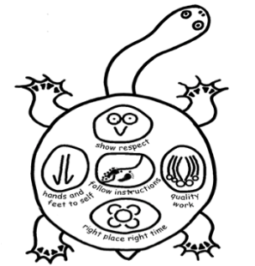

K-4 Merit System

Students will be rewarded with a merit stamp for the following reasons:

* Receiving a Proud and Positive letter
* Consistent application in class
* Achieving excellent results in assessment tasks
* Consistently following school goals
* Completion of homework

Each merit card has 20 places for stamps. When a student completes a card, he / she moves onto another one. The number of cards needed to progress up to the next levels are listed.

**Years K - 4 Merit System**

Bronze - 4 Merit Cards

Silver - 8 Merit Cards

Gold - 12 Merit Cards

Opal - 16 Merit Cards

Students will be presented with their level certificates at appropriate school assemblies.

The Principal and/or Deputy Principals have the option to move a student down a level. Suspensions and in School Withdrawals will result in the student being moved back to the start of the existing level.

Years 5-12 Merit System

Students will be rewarded with a merit for the following reasons:

* Receiving a Proud and Positive letter
* Consistent application in class
* Achieving excellent results in assessment tasks
* Consistently following school goals
* Completion of homework

As students present merit cards to their year advisor/ roll call teacher, who will record their progress, these students will progress up the merit levels from potch to opal level. These students will be entitled to the privileges corresponding to each level as set out in the award chart. Please see Appendix 2.

**Year 5 - 12 Merit System**

Bronze – 20 Merit Cards

Silver - 40 Merit Cards

Gold - 60 Merit Cards

Opal - 80 Merit Cards

These students will be presented with their level certificates at weekly assemblies.

The Principal and/or Deputy Principals has the option to move a student down a level. Suspensions and In School Withdrawals (ISW) may result in the student being moved back to the start of the preceding level.

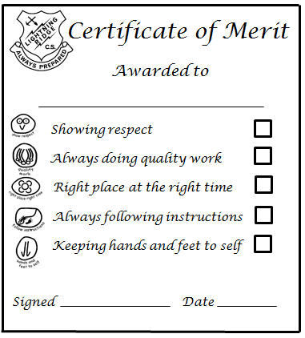

Lightning Ridge Central School

**Suspension and Expulsion Policy**

Suspension allows children the time to reflect on their behaviour, to acknowledge and accept responsibility for the behaviour that led to the suspension and to act positively to change their behaviour in order to meet the school’s expectations in the future.

The procedures apply to the behaviour of students at school, on the way to and from school and while away from the school site on school-endorsed activities e.g. excursions and sporting activities.

It is the principal’s responsibility to exercise judgement based on the student’s record, the degree & length of support given to the student, the response of the student & the circumstances of the misbehaviour.

A process of procedural fairness will ensure:

* the student’s right to know about the allegations and actions, and the right to respond to them
* the student’s right to an unbiased decision.

Suspension may be “short” (up to & including 4 school days) or “long” (up to & including 20 school days).

**A ‘short’ suspension may be imposed for:**

* **Continued disobedience** including defiance, disruption to other students, minor criminal behaviour, use of alcohol or the persistent use of tobacco
* **Aggressive behaviour** including, but not limited to, hostile behaviour directed at any member of the school community such as verbal abuse or sending abusive electronic messages

**A ‘long’ suspension will be imposed immediately and consistently for:**

* Physical violence
* Being in possession of a firearm, prohibited weapon or knife without reasonable cause
* Use or possession of an illegal substance (not alcohol or tobacco) or supplying a restricted substance
* Persistent misbehaviour
* Use of an implement as a weapon or threatening to use a weapon
* Serious criminal behaviour relating to the school

During the period of suspension the school counsellor will complete a Suspension Report.

**Return from Suspension Procedure:**

All students who return from suspension must participate in a successful return from suspension meeting with the Principal or their delegate, year advisor (secondary) and a parent/carer. Following this meeting students will return to school. Except in exceptional circumstances students will spend 2 periods in the senior study and complete one session of PBL Guidance and be placed on *White Level Monitoring Book* for (min) 5 days. Please refer to Appendix 3. This will impose restrictions on their ability to participate in school activities.

**Expulsion:**

In serious circumstances of misbehaviour, the principal may expel a student of any age from their school. The principal may also expel a student who is over 17 years of age for unsatisfactory participation in learning. The principal may expel students in line with the NSW DEC’s Suspension and Expulsion Policy.

|  |  |
| --- | --- |
| Behaviour Monitoring Levels | |
| **Level 1 – Yellow** | **Level 2 - Orange** |
| **Behaviours**   * Misbehaviour in the classroom or playground   + For example; constant disruption, anti-social behaviour, constant work avoidance, constant disobedience, 1st instance of inappropriate use of electronic device etc. | **Behaviours**   * Failure to satisfactorily complete yellow monitoring card (2 days) * Referral to HT/AP/DP whilst on yellow monitoring card * Aggressive behaviour in classroom or playground (low level) * Swearing * Truancy * Bullying * Continuation or increased level of misbehaviour from yellow level |
| **Strategies**   * Yellow monitoring card (2 days) * CT/AP/HT to make parent contact * CT to reassess Class Behaviour Management Plan (CBMP) * CT to insure behaviours are entered on SALM * Assess need for L&ST referral. | **Strategies**   * Orange monitoring card (3 days) * AP/HT/DP parent contact * CT to reassess CBMP * CT to insure behaviours are entered on RISC * Assess need for L&ST referral |
| **Consequences**   * Telephone call to parent/carer and an official letter home * Inability to attend school excursions for the duration of monitoring book * Loss of classroom privileges | **Consequences**   * Telephone call to parent/carer and an official letter home. * Inability to attend school excursions for the duration of monitoring book * Loss of classroom privileges. * Students with less than 3 crosses will not receive recess or lunch school beautification duty on day 3. * Possible In School Withdrawal determined by (HT/AP/DP) |

|  |
| --- |
| Behaviour Monitoring Levels |
| **Level 3- White** |
| **Behaviours**   * Physical Violence * Continual and severe misbehaviour in classroom or playground (including bullying) * Criminal behaviour (weapons, drugs etc.) * Aggressive behaviour (including swearing at staff) |
| **Strategies**   * White monitoring card (5 days) * DP/P to contact parent * CT to reassess CBMP * CT to ensure behaviours are entered on SALM * Assess need for L&ST referral |
| **Consequences**   * Inability to attend school excursions for the duration of monitoring book * Loss of classroom privileges. * In school withdrawal (determined by (HT/AP/DP) * Suspension (determined by Principal) |

|  |  |  |
| --- | --- | --- |
| Negative Behaviour Possible Consequences | | |
| **Behaviour** | **Likely Consequence** | **Further Action** |
| **Aggressive Behaviour** | * Parent contact * Acceptable Behaviour Agreement * Refer to executive * Executive PBL Guidance * Withdrawal * In School Withdrawal * Suspension * Police Contact * Supervised Senior Study | * Referral to Learning Support Teacher * Create or review and implement a Behaviour Management Plan * Create or review and implement Risk Management Plan * Acceptable Behaviour Agreement |
| **Disruption** | * Teacher intervention * Class detention * Parent contact * Acceptable Behaviour Agreement | * Referral to AP/HT * Acceptable Behaviour Agreement |
| **Continual Disruption** | * Teacher intervention * Parent contact * Refer to executive * Executive PBL Guidance * Acceptable Behaviour Agreement * Withdrawal * In School Withdrawal * Suspension (continual and severe) * Supervised Senior Study | * Referral to Learning Support Teacher * Create or review and implement a Behaviour Management Plan * Create or review and implement Risk Management Plan * Acceptable Behaviour Agreement |
| **Disobedience** | * Teacher intervention * Class detention * Acceptable Behaviour Agreement * Parent contact | * Referral to AP/HT * Acceptable Behaviour Agreement |
| **Continual Disobedience** | * Teacher intervention * Parent contact * Refer to executive * Acceptable Behaviour Agreement * Executive PBL Guidance * Withdrawal * In School Withdrawal * Suspension (continual and severe disobedience) * Supervised Senior Study | * Referral to Learning Support Teacher * Create or review and implement a Behaviour Management Plan * Create or review and implement Risk Management Plan * Acceptable Behaviour Agreement |
| **Indecency** | * Teacher intervention * Parent contact * Refer to executive * Acceptable Behaviour Agreement * Executive PBL Guidance * Withdrawal * In School Withdrawal * Suspension * Police Contact | * Referral to Learning Support Teacher * Create or review and implement a Behaviour Management Plan * Create or review and implement Risk Management Plan * Acceptable Behaviour Agreement |
| **Behaviour** | **Likely Consequence** | **Further Action** |
| **Inciting Violence** | * Teacher intervention * Parent contact * Acceptable Behaviour Agreement * Refer to executive * Executive PBL Guidance * Withdrawal * In School Withdrawal * Suspension * Police contact * Supervised Senior Study | * Referral to Learning Support Teacher * Create or review and implement a Behaviour Management Plan * Create or review and implement Risk Management Plan * Acceptable Behaviour Agreement |
| **Inappropriate use of electronic device** | * Confiscation * Acceptable Behaviour Agreement * Parent contact * Refer to executive * Executive PBL Guidance * Police contact * Supervised Senior Study | * Referral to relevant training programs * (ACMA, or Police Liaison Officer) * Acceptable Behaviour Agreement |
| **Out of Bounds** | * Teacher intervention * Class detention * Acceptable Behaviour Agreement * Executive PBL Guidance * Parent contact | * Acceptable Behaviour Agreement |
| **Aggressive repeated or highly inappropriate Swearing** | * Teacher intervention * Parent contact * Refer to executive * Acceptable Behaviour Agreement * Class detention * Executive PBL Guidance * Withdrawal * In School Withdrawal * Suspension * Police Contact * Supervised Senior Study | * Referral to Learning Support Teacher * Create or review and implement a Behaviour Management Plan * Create or review and implement Risk Management Plan * Acceptable Behaviour Agreement |
| **Swearing at or in the presence of Staff** | * Suspension * Withdrawal | * Referral to Learning Support Teacher * Create or review and implement a Behaviour Management Plan * Create or review and implement Risk Management Plan * Acceptable Behaviour Agreement |
| **Smoking or being in the presence of smokers** | * Suspension * Warning Letter * Police Contact | * Referral to the QUIT program * Acceptable Behaviour Agreement |
| **Threatening staff** | * Suspension * Police Contact | * Referral to Learning Support Teacher * Create or review and implement a Behaviour Management Plan * Create or review and implement Risk Management Plan * Acceptable Behaviour Agreement |
| **Behaviour** | **Likely Consequence** | **Further Action** |
| **Truanting (Including partial and in-school truancy)** | * Teacher intervention * Class detention * Executive PBL Guidance * Acceptable Behaviour Agreement * Parent contact * Suspension (continual and severe) * Police Contact | * Referral to HSLO * Referral to Learning Support Teacher * Create or review and implement Risk Management Plan * Acceptable Behaviour Agreement |
| **Inappropriate Touching** | * Teacher intervention * Verbal warning * Acceptable Behaviour Agreement * Parent contact * Executive PBL Guidance * Class detention | * Acceptable Behaviour Agreement |
| **Vandalism** | * Teacher intervention * Parent contact * Refer to executive * Executive PBL Guidance * Acceptable Behaviour Agreement * In School Withdrawal * Suspension * Police Contact | * Acceptable Behaviour Agreement |
| **Violence** | * Suspension * Police Contact * Review merit level | * Referral to Learning Support Teacher * Create or review and implement a Behaviour Management Plan * Create or review and implement Risk Management Plan * Acceptable Behaviour Agreement |

***Senior Study***

**DAY 1**

**1 full day consisting of 5 periods**

**Lunch and recess in executive detention**

**Behaviour**

**GOOD**

**POOR**

**Home**

**DAY 2**

**Period 1/2 (Senior Study)**

**Executive PBL Guidance at Recess**

**Period 3 (Senior Study)**

**POOR**

**GOOD**

**Home**

**Period 4/5 (Back to class)**

**No more PBL Guidance**

**Classroom Discipline Process**

**Level 1 Behaviours**

**Examples include:** off task, disruptive, refusal to follow instructions, speaking rudely.

**Level 2 Behaviours**

**Examples include** swearing, low level aggression, continual disobedience and disruption, absconding from class, vandalism,

**Level 3 Behaviours**

**Examples include**: violence, swearing at staff, and possession of weapons/illegal substances

If this process is repeated several times in a day treat as a level 2 behaviour.

**Deputy Principal / Principal**

Student is removed to DP/P. DP/P make contact with parent/carer. DP/P consults Welfare and Discipline Policy for appropriate consequence. DP/P may impose a suspension or in school withdrawal for level 3 behaviours.

**Thinking Time / Detention**

Student is given 5-10 minutes thinking time in a designated classroom space or in a buddy classroom.

**Executive Time Out / Senior Study**

Student is removed from classroom to an executive staff member for a negotiated period of time. Parent / carer contact is made by HT/AP or CT. Detention is given and reflection sheet completed.

**2nd Reminder**

Teacher reminds student of school rule again and possible consequence. Provide another visual reinforcement.

**1st Reminder**

Teacher reminds student of school rule again and possible consequence. Provide visual reinforcement.

**Redirection**

Teacher reminds student of school rule.

**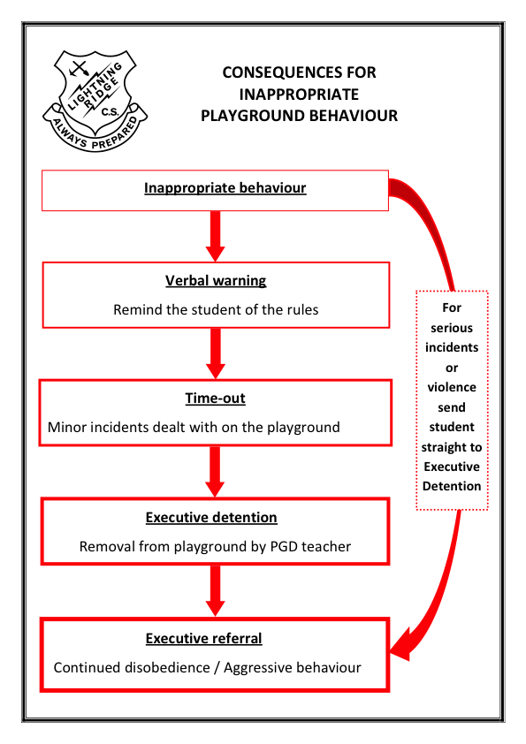**

**PBL Guidance**

**For serious incidents or physical violence send straight to PBL Guidance**

OCA

|  |
| --- |
| ***What is an OCA?***  It is an **O**ut of **C**lass **A**uthority.  ***When is an OCA used?***  Every time a student is not in a classroom, during lesson time they must be in the possession of an OCA. This is their authority or permission to be out of class.  **.**  **Examples of when students must have an OCA in their possession;**  Every time they leave the classroom for any reason.  Including but not limited to:   * To go to the toilet * To go to the front office * To go to the library * To go to the staffroom * To work or sit outside a classroom   **Student responsibility:**   * If students wish to leave the classroom they must ask the teacher for an OCA. The teacher reserves the right to decide if the student will be allowed to leave and given an OCA. * The student may fill out the OCA but the teacher must check and sign it. * Students must have the OCA in their possession when they are out of class, during lesson time.   **Teacher responsibility:**  It is the teacher’s responsibility to ensure an OCA is issued if a student is out of their room with permission  If a teacher sees a student out of class, during lesson time, they must ask the student to show the OCA slip. If the student does not have an OCA record this in SALM as *partial truancy* and return the student to their classroom.  The **class teacher** must place the student on class detention whenever students leave class without an OCA. |

Non-Classroom Settings Expectations

K-4 and Shared Areas

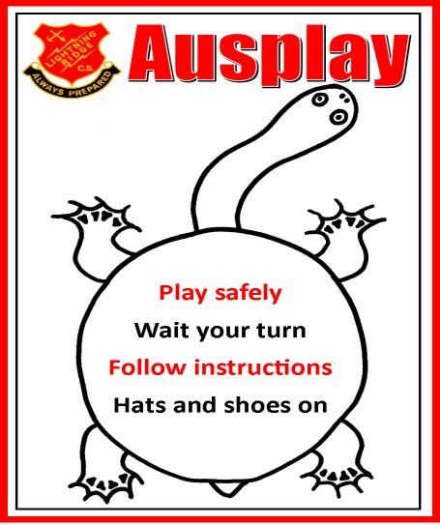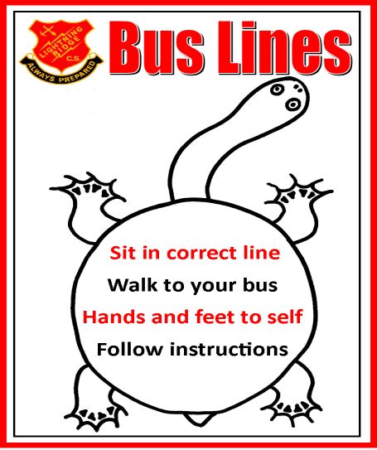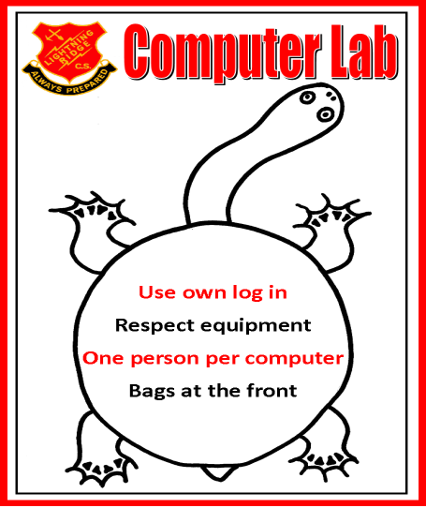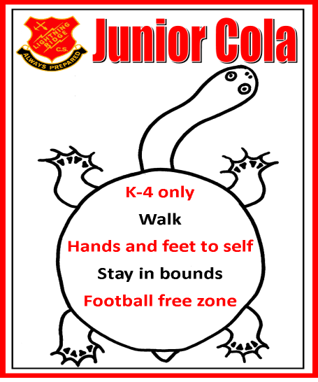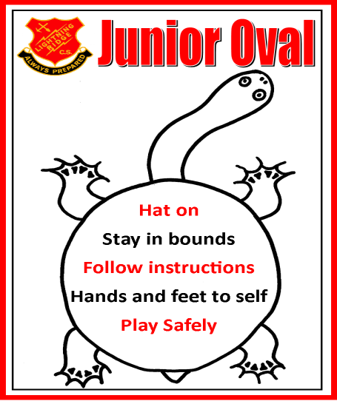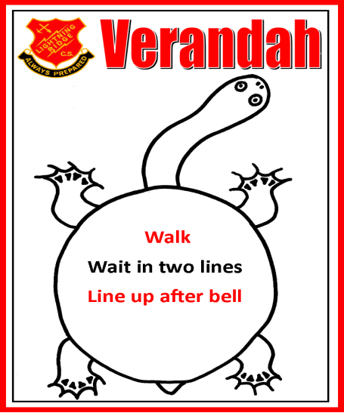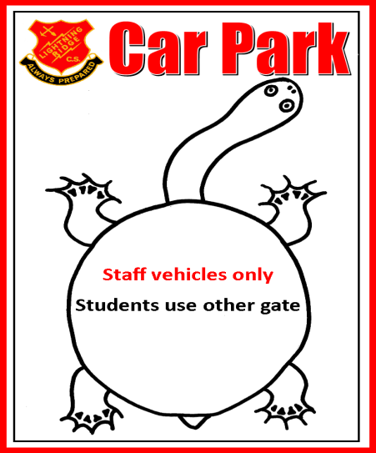

5-12 and Shared Areas

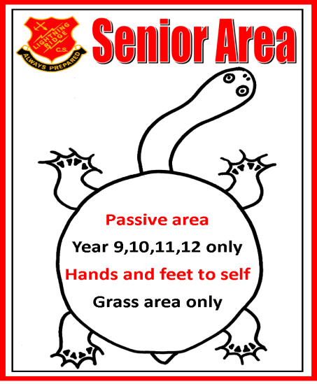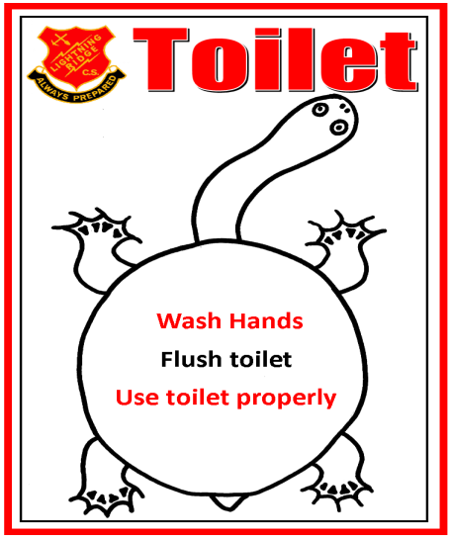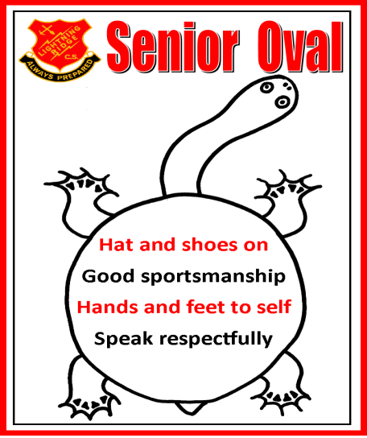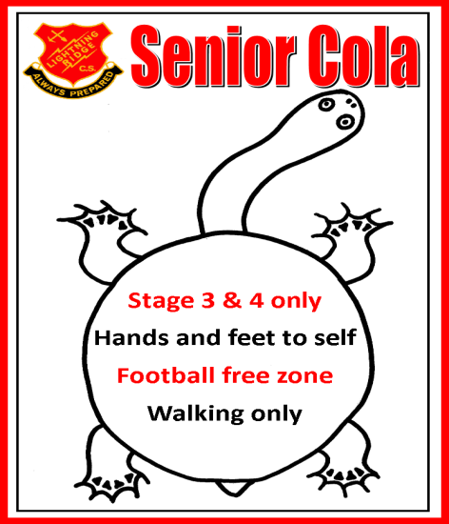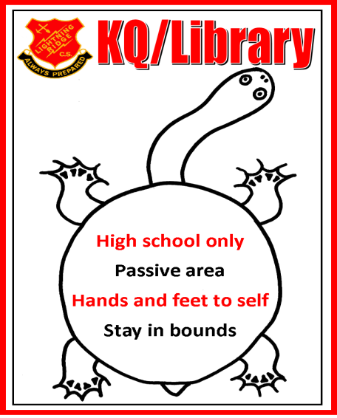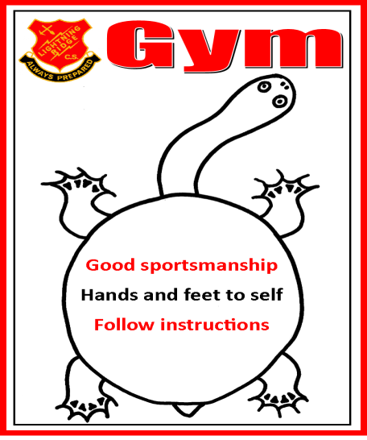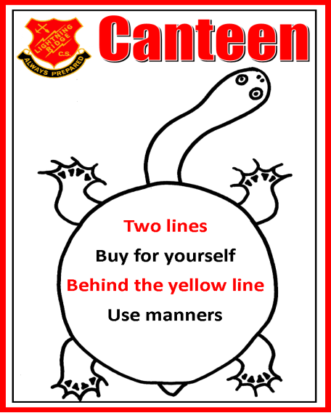

**Lightning Ridge Central School**

**sch_logoAcceptable Behaviour Agreement**

Student Name: \_\_\_\_\_\_\_\_\_\_\_\_\_\_\_\_\_\_\_\_\_\_\_\_\_Class: \_\_\_\_\_\_Date: \_\_\_\_\_\_\_

I, \_\_\_\_\_\_\_\_\_\_\_\_\_\_\_\_\_\_\_\_\_\_\_\_\_ accept that I have demonstrated

unacceptable behaviour involving \_\_\_\_\_\_\_\_\_\_\_\_\_\_\_\_\_\_\_\_\_\_\_\_\_\_\_\_\_\_\_\_\_\_\_\_\_\_\_\_\_\_

\_\_\_\_\_\_\_\_\_\_\_\_\_\_\_\_\_\_\_\_\_\_\_\_\_\_\_\_\_\_\_\_\_\_\_\_\_\_\_\_\_\_\_\_\_\_\_\_\_\_\_\_\_\_\_\_\_\_\_\_\_\_\_\_\_\_\_\_\_\_

\_\_\_\_\_\_\_\_\_\_\_\_\_\_\_\_\_\_\_\_\_\_\_\_\_\_\_\_\_\_\_\_\_\_\_\_\_\_\_\_\_\_\_\_\_\_\_\_\_\_\_\_\_\_\_\_\_\_\_\_\_\_\_\_\_\_\_\_\_\_

\_\_\_\_\_\_\_\_\_\_\_\_\_\_\_\_\_\_\_\_\_\_\_\_\_\_\_\_\_\_\_\_\_\_\_\_\_\_\_\_\_\_\_\_\_\_\_\_\_\_\_\_\_\_\_\_\_\_\_\_\_\_\_\_\_\_\_\_\_\_

\_\_\_\_\_\_\_\_\_\_\_\_\_\_\_\_\_\_\_\_\_\_\_\_\_\_\_\_\_\_\_\_\_\_\_\_\_\_\_\_\_\_\_\_\_\_\_\_\_\_\_\_\_\_\_\_\_\_\_\_\_\_\_\_\_\_\_\_\_\_

\_\_\_\_\_\_\_\_\_\_\_\_\_\_\_\_\_\_\_\_\_\_\_\_\_\_\_\_\_\_\_\_\_\_\_\_\_\_\_\_\_\_\_\_\_\_\_\_\_\_\_\_\_\_\_\_\_\_\_\_\_\_\_\_\_\_\_\_\_\_

I agree to

\_\_\_\_\_\_\_\_\_\_\_\_\_\_\_\_\_\_\_\_\_\_\_\_\_\_\_\_\_\_\_\_\_\_\_\_\_\_\_\_\_\_\_\_\_\_\_\_\_\_\_\_\_\_\_\_\_\_\_\_\_\_\_\_\_\_\_\_\_\_

\_\_\_\_\_\_\_\_\_\_\_\_\_\_\_\_\_\_\_\_\_\_\_\_\_\_\_\_\_\_\_\_\_\_\_\_\_\_\_\_\_\_\_\_\_\_\_\_\_\_\_\_\_\_\_\_\_\_\_\_\_\_\_\_\_\_\_\_\_\_

\_\_\_\_\_\_\_\_\_\_\_\_\_\_\_\_\_\_\_\_\_\_\_\_\_\_\_\_\_\_\_\_\_\_\_\_\_\_\_\_\_\_\_\_\_\_\_\_\_\_\_\_\_\_\_\_\_\_\_\_\_\_\_\_\_\_\_\_\_\_

\_\_\_\_\_\_\_\_\_\_\_\_\_\_\_\_\_\_\_\_\_\_\_\_\_\_\_\_\_\_\_\_\_\_\_\_\_\_\_\_\_\_\_\_\_\_\_\_\_\_\_\_\_\_\_\_\_\_\_\_\_\_\_\_\_\_\_\_\_\_

\_\_\_\_\_\_\_\_\_\_\_\_\_\_\_\_\_\_\_\_\_\_\_\_\_\_\_\_\_\_\_\_\_\_\_\_\_\_\_\_\_\_\_\_\_\_\_\_\_\_\_\_\_\_\_\_\_\_\_\_\_\_\_\_\_\_\_\_\_\_

\_\_\_\_\_\_\_\_\_\_\_\_\_\_\_\_\_\_\_\_\_\_\_\_\_\_\_\_\_\_\_\_\_\_\_\_\_\_\_\_\_\_\_\_\_\_\_\_\_\_\_\_\_\_\_\_\_\_\_\_\_\_\_\_\_\_\_\_\_\_

I understand that the consequences of breaking this contract will be:

\_\_\_\_\_\_\_\_\_\_\_\_\_\_\_\_\_\_\_\_\_\_\_\_\_\_\_\_\_\_\_\_\_\_\_\_\_\_\_\_\_\_\_\_\_\_\_\_\_\_\_\_\_\_\_\_\_\_\_\_\_\_\_\_\_\_\_\_\_\_

\_\_\_\_\_\_\_\_\_\_\_\_\_\_\_\_\_\_\_\_\_\_\_\_\_\_\_\_\_\_\_\_\_\_\_\_\_\_\_\_\_\_\_\_\_\_\_\_\_\_\_\_\_\_\_\_\_\_\_\_\_\_\_\_\_\_\_\_\_\_

\_\_\_\_\_\_\_\_\_\_\_\_\_\_\_\_\_\_\_\_\_\_\_\_\_\_\_\_\_\_\_\_\_\_\_\_\_\_\_\_\_\_\_\_\_\_\_\_\_\_\_\_\_\_\_\_\_\_\_\_\_\_\_\_\_\_\_\_\_\_

I understand that, if I have a problem resolving conflict, I ask a teacher for help in order to learn better ways to deal with my problem.

Student’s Signature: \_\_\_\_\_\_\_\_\_\_\_\_\_\_\_\_\_\_\_\_\_\_\_\_\_\_\_\_\_\_\_\_\_\_\_\_

Parent /Carer: \_\_\_\_\_\_\_\_\_\_\_\_\_\_\_\_\_\_\_\_\_\_\_\_\_\_\_\_\_\_\_\_\_\_\_\_

AP/HT: \_\_\_\_\_\_\_\_\_\_\_\_\_\_\_\_\_\_\_\_\_\_\_\_\_\_\_\_\_\_\_\_\_\_\_\_

Date: \_\_\_\_\_\_\_\_\_\_\_\_\_\_\_\_\_\_\_\_\_\_\_\_\_\_\_\_\_\_\_\_\_\_\_\_

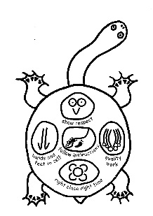sch_logo5-12 PBL Guidance Reflection Sheet

|  |
| --- |
| Name: …………………………………………. Date: …………………………………   1. What happened? Explain how you were involved and what you did?   ................................................................................................................................................................  ................................................................................................................................................................  ................................................................................................................................................................  ................................................................................................................................................................   1. What were you thinking of at the time?   ................................................................................................................................................................  ................................................................................................................................................................  ................................................................................................................................................................  ................................................................................................................................................................   1. Who has been affected by what you have done? In what way?   ................................................................................................................................................................  ................................................................................................................................................................  ................................................................................................................................................................  ................................................................................................................................................................   1. What do you think you need to do to make things right?   ................................................................................................................................................................  ................................................................................................................................................................  ................................................................................................................................................................  ................................................................................................................................................................  ................................................................................................................................................................ |

|  |  |  |  |  |
| --- | --- | --- | --- | --- |
| sch_logo | **K–4 Reflection Sheet** | | | |
| Name |  | | Date |
|  |  |  |  |
| Trace the School Rules.  Show respect  Right place, right time  Hands and feet to self  Follow instructions  Quality work | | | |  |
| What rule did you break? | | | | |
| Draw or write about your behaviour. What happened? | | | | |
| How did your behaviour affect others? | | | | |
| Draw or write what happens when you follow the rules. | | | | |

Lightning Ridge Central School

sch_logoAnti-Bullying Policy

***STATEMENT OF PURPOSE***

Every person at Lightning Ridge Central School has the right to experience positive and respectful relationships between all members of the school community. They also have the right to learn and teach in a happy and safe environment free from fear of bullying, harassment and intimidation. Bullying behaviour therefore is not acceptable at Lightning Ridge Central School.

Bullying is repeated verbal, physical, social or psychological behaviour that is harmful and involves the misuse of power by an individual or group towards one or more persons. Cyber bullying refers to bullying through information and communication technologies.

Bullying can involve humiliation, domination, intimidation, victimisation and all forms of harassment including that based on gender, race, disability, homosexuality or transgender. Bullying of any form or for any reason can have long-term effects on those involved including bystanders.

Conflict or fights between equals or single incidents are not defined as bullying.

It is our aim at Lightning Ridge Central School to be a happy and safe school where all members of the school community promote student and staff wellbeing.

***PROTECTION***

**What is bullying?**

We can define bullying as **ongoing** **intimidation of a physical, verbal or psychological nature of a less powerful person by a more powerful person or group of persons**. School bullying can include teasing, exclusion, gesture bullying, abuse, threats, assault, property damage and malicious gossip.

Bullying behaviour can be:

* **verbal** e.g. name calling, teasing, abuse, putdowns, sarcasm, insults, threats;
* **physical** e.g. hitting, punching, kicking, scratching, tripping, spitting;
* **social** e.g. ignoring, excluding, ostracising, alienating, making inappropriate gestures;
* **psychological** e.g. spreading rumours, dirty looks, hiding or damaging possessions, malicious SMS and email messages, inappropriate use of camera phones;
* **cyber bullying** is an intentional, repeated behaviour by an individual or group to cause distress or undue pressure to others using technology e.g. email, chatroom, SMS / texting, social networks, video clips, phone calls.

The term “bullying” has a specific meaning. The school’s Anti-bullying Plan sets out **the processes for preventing and responding to student bullying**. The school has a range of policies and practices, including welfare and discipline policies that apply to student behaviour generally.

Schools exist in a society where incidents of bullying behaviour may occur. Preventing and responding to bullying behaviour in learning and working environments is a shared responsibility of all departmental staff, students, parents, caregivers and members of the wider school community.

***PREVENTION***

**How will we address bullying and harassment at Lightning Ridge Central School?**

The strategies listed below try to develop an awareness amongst the school community of the nature and consequences of bullying and harassment, how they can help to decrease it, and what to do if they are bullied or harassed.

They also aim to network students so as to strengthen peer acceptance and support.

* Buddies – giving young children an older student in which to confide.
* Talks at assembly – to reinforce that bullying is not acceptable.
* Special days – eg Harmony Day.
* Regular Student Welfare Team and Learning Support Team meetings.
* Individual conference with victims and bullies.
* Increasing bullying awareness within the PD / Health / PE Program.
* Visiting performances.
* Positive behaviour program
* Cyber bullying posters / programs – in class and on our website.
* Professional learning for staff around bullying and cyber bullying.
* Bounce Back Program
* Rage Program
* Core values

Strategies for dealing with bullying are linked to the School Welfare Policy and encompass a range of options available to deal with unacceptable behaviours, including suspension and expulsion.

In dealing with bullying behaviour, there is a need to recognise the repeated and recurring nature of bullying and have mechanisms in place to identify patterns of repeated offending.

***What should we do if we are, or see others, being bullied?***

Students who are being bullied and students who have received reports of bullying and harassment from their peers should refer these on to teachers.

Through school assemblies, the school newsletter and peer programs, the importance of reporting bullying at Lightning Ridge Central School is emphasised. All reports of bullying will be taken seriously and handled in a sensitive manner.

***EARLY INVENTIONS***

For students identified as being at risk of developing long term difficulties with social relationships and / or history of being bullied or engaging in bullying behaviour, the school implements a range of programs. These include:

* Behaviour support for students identified by their classroom teacher.
* Access to and counselling by the Assistant Principals Head Teachers, Deputy Principals, Principal and the School Counsellor.
* Individual conferences with victims and bullies and families if necessary.
* Classroom management and positive reinforcement programs.
* Friendship group sessions and social stories from Learning Support Team and School Counsellor.
* Risk assessments.
* Health care plans.

***RESPONSE***

If bullying or harassment occurs, the following actions outlined should be taken.

***For students:***

* Tell your teacher (preferably your class, or playground teacher) immediately. You **may** also tell your Peer Support Leader, School Counsellor, Assistant Principal or Principal.
* Teachers to follow current welfare system. They will then interview bullies and victims.
* Where the bullying involves a serious physical assault, you should immediately report the incident to the Assistant Principal Head Teacher Deputy Principal or the Principal.

***For staff:***

* You listen and acknowledge the seriousness of the report, no matter how trivial it may at first appear. Question the child to see if this or other such incidents have happened before.
* Follow current welfare system and interview bullies and victims.
* Time out if necessary.
* Teacher to complete the School Anti-bullying Record Sheet.

***For parents / caregivers:***

* Encourage your children to discuss bullying as much as possible. A thorough reading of this plan with your children is highly recommended.
* Discuss with your child strategies to help them deal with the issue.
* Encourage them to follow the procedures outlined above, if they report bullying.
* Contact the school, if your child’s efforts to deal with the bullying do not appear to be working.
* When the school’s attempts to deal with reported bullying and victimisation do not appear to be working, your assistance may well be sought. In cases of serious physical bullying parents will automatically be involved.

***IN CONCLUSION***

Bullying exists at all levels in our society. We know that the effects of bullying on learning and general adjustment at school can be far reaching for the students involved. We trust that the whole school community can share the responsibility in maintaining a peaceful and safe learning environment.

**School staff** have a responsibility to:

* respect and support students,
* model and promote appropriate behaviour, and
* respond in a timely manner to incidents of bullying according to the school’s Anti-bullying Plan.

In addition, teachers have a responsibility to:

* provide curriculum and pedagogy that supports students to develop an understanding of bullying and its impact on individuals and the broader community.

**Students** have a responsibility to:

* behave appropriately, respecting individual differences and diversity,
* behave as responsible digital citizens,
* follow the school Anti-bullying Plan,
* behave as responsible bystanders, and
* report incidents of bullying according to their school Anti-bullying Plan.

**Parents and caregivers** have a responsibility to:

* support their children to become responsible citizens and to develop responsible online behaviour,
* be aware of the school Anti-bullying Plan and assist their children in understanding bullying behaviour,
* support their children in developing positive responses to incidents of bullying consistent with the school Anti-bullying Plan,
* report incidents of school related bullying behaviour to the school, and
* work collaboratively with the school to resolve incidents of bullying when they occur.

**All members of the school community** have a responsibility to:

* model and promote positive relationships that respect and accept individual differences and diversity within the school community,
* support the school’s Anti-bullying Plan through words and actions, and
* work collaboratively with the school to resolve incidents of bullying when they occur. The plan will be reviewed annually by the PBL Team, P & C, students and staff to evaluate its effectiveness.

Bullying Action Plan

Preventative Strategies

All students have access to bullying prevention education. This may include access to the following: Resiliency programs, The RAGE program, Peer Support Program, The Bullying No Way Website, The Kids Smart Website, PBL lesson plans, etc.

If bullying occurs despite preventative measures being implemented follow the flow chart:

**The Student**

Reports the incident to a teacher or member of staff. Practices ‘No, Go, Tell’

**Bystanders**

Reports the incident to a teacher or member of staff. Helps the student being bullied to ‘No Go Tell’

**Parents**

Discuss issues with child. Contact child’s teacher/year advisor/deputy principal

Member of Staff takes action according the Student Welfare and Discipline Policy. Staff will record incident in SALM

salm

Issue is Resolved

Incident taken to Learning and Support Team for action

Issue not resolved

Executive Support

sch_logoLightning Ridge Central School

Anti-Racism Policy

**Rationale and Purpose**

In recent years, Australians have become increasingly aware of the role of various forms of racism in Australian history and society as a whole. Silence and denial are fundamental to racism. Racism is perpetuated by silence and denial. Those who suffer most from racism must be given the means whereby they can have confidence in the various mechanisms to combat and challenge the unacceptable. While the external avenues are important the school must provide mechanisms for action. These procedures and structures are a means of addressing racism in a way that promotes effective redress and racial harmony. Lightning Ridge Central School rejects racism in all its forms. It is committed to the elimination of racial discrimination of any kind.

**In order to achieve these outcomes, at Lightning Ridge Central School specifically we will:**

* Counteract the causes and redress the effects of racism in the context of the school, the school community and the curriculum.
* Protect the rights of students and staff to achieve their full potential in an environment which encourages the affirmation of their cultural identity.
* Provide those who need it with a range of avenues of complaint and redress.
* Ensure that everyone in the school understands and fulfils their responsibilities in the implementation of this policy.
* Appoint a teacher to be trained as the Anti Racism Contact Officer (ARCO).
* Maintain a register of reports of racism.

**The Principal will:**

* Allocate resources and responsibilities for the implementation of the policy.
* Ensure that the school community is familiar with the Anti-Racism Policy and the grievance procedures.
* Develop, implement, review and evaluate the Anti-Racism Policy.
* Assist staff in developing strategies for addressing racism in appropriate subject areas and across the curriculum.
* Intervene to prevent racism from occurring and to redress its effects if preventative measures are not possible.
* Monitor implementation of the policy and the working environment in its effects if preventative measures are not possible.

**Executive and Teaching staff will:**

* Ensure that curriculum content and teaching methods are congruent with and support the Anti-racism policy.
* Develop strategies in the school for increasing student understanding of racism.
* Monitor the school environment in terms of racist attitudes and behaviours and intervene to prevent racism from occurring in the school environment.

**sch_logoLightning Ridge Central School**

Anti-Racism Plan

**Step 1:** Clarify that the issue is race related.

**Step 2:** Discuss incident with students involved and take statements.

**Step 3:** Inform Anti-Racism Contact Officer (ARCO).

**Step 4:** Hold an interview with students concerned, following the below process:

* Discuss the incident
* Let both sides explain their point of view
* Explain why the comments are inappropriate/offensive
* Seek an apology from the appropriate person
* During the meeting, decide on any appropriate disciplinary action. This action should be in line with the schools Discipline Policy.

**Step 5:** Contact parents. Inform them if the issue has been revolved or not. If the issue has not been satisfactorily resolved, the issue is then referred onto the principal.

**Possible Disciplinary Action**

**Low Level**

* Detention
* Parent Contact
* Executive PBL Guidance

**High Level**

* In-school withdrawal
* Suspension

**Preventive Measures**

* Inform yourself of the DEC’s Anti- Racism Policy
* Visit <http://www.racismnoway.com.au> and complete the lessons and activities with your students.
* Visit <http://www.reconciliation.org.au> and complete the lesson and activities with your students.
* Visit <http://www.naidoc.org.au/> and complete the lesson and activities with your students.

**Racism Stops with Me**

Learning and Support Team

The Learning and Support Team meets every week. At the weekly meeting teachers have the opportunity to refer students if they have concerns about their learning or behaviour. Teachers should follow the flow chart below before making a referral.

|  |  |
| --- | --- |
| Prior to Referral to the Learning and support team | |
| Class teacher + supervisor : | |
| * Consider adjustments, | * collect data – |
| * look at learning history of the student | * note any issues or incidents |
| * contact parents/carers | * list strategies attempted and evaluations |

School L&S team refer student/students as individual or part of group intervention

**Exit** procedure or further referral as required

Files stored electronically on school server

**Exit** procedure or further referral as required

Files stored electronically on school server

**Set up file** – identify a case manager, determine stakeholders. Contact Parents/carers

**Data collection**

Includes: info from school L&S team, direct /indirect observations, past interventions, checklists, curriculum based assessments, Standardised assessments, interview, student files, pupil record card, LMBR data

**Analyse data** to identify and prioritise student needs – in consultation with others if required.

**Identify the issue that is preventing access to the curriculum**

**Collaborative planning (in person if possible)**

Individual Learning Support Team meeting

Record of the meeting- eg L&SP, PLP, behaviour plan,

* Indicators identified and agreed
* Review date set
* Any staff Professional Learning identified
* parent signature on plan – Add to file

**Collaborative planning (in person if possible)**

Group intervention

Record of meeting/s- eg L&S plan, PLP, OOHCP, behaviour plan, literacy plan etc

* Indicators identified and agreed
* Review date set
* Any staff Professional Learning identified
* parents signatures on plan – file

**Exit** procedure or further referral as required to Disability Programs Consultant.

Files stored electronically on school server

**Program & Implement** adjustments from learning and support planning meeting

**Monitor and evaluate** implementation

Review and modify as needed- update file

Feedback to school L&S team

Possible Outcomes after an LST Referral

|  |  |
| --- | --- |
| Exceptional Student Information collected and returned to LAST Team | LAST Team to complete Report on Exceptional Student and share with relevant staff |
| Individual Education Plan (IEP) written with assistance from LAST member | Learning program to be developed by teacher and Learning Support Officer if needed |
| Risk Management Checklist to be completed by relevant staff and returned to LAST Team | Risk Management Plan written and discussed with staff |
| Outside agencies contacted | * Irlen * Royal Far West * Counsellor * Hearing Testing * HSLO |
| Access Request Form completed | Possible Funding support/Aide time  Access Request Form |
| Further parent contact |  |

Attendance Team

The Attendance Team meets fortnightly with the Home School Liaison Officer (HSLO) and Aboriginal Community Liaison Officer (ACLO) to discuss any issues with student attendance and to suggest and implement strategies to support better attendance. The Attendance Team then reports to the Learning and Support Team recommends further action if required. The Attendance Team consists of the School Administrative Officer responsible for attendance, the Principal, the Deputy Principals, Instructional Leader K-2 and the Aboriginal Education Officers (AEO).

Lighting Ridge Central School Mission Statement and Goals

(Appendix 1)

|  |
| --- |
| *At Lightning Ridge Central School we create positive, safe and respectful learning environments that engage students in quality lessons celebrate success and promote lifelong learning.* |

Lightning Ridge Central School has five core goals, which assist to maintain a positive learning environment.

These goals are designed to cover all settings including classroom and playground environments, representing the school, travelling to and from school and while attending excursions, arts or sporting events.

Our five goals are:

|  |  |
| --- | --- |
|  | **Quality Work**  This symbol represents a bowerbird's display, because they work so hard on these and they have to be perfect. |
|  | **Right Place Right Time**  This symbol represents a meeting symbol (the imprint that is left in the sand after people come together for a meeting), to demonstrate the idea of protocol and Law in knowledge exchange. |
|  | **Hands and feet to self**  This symbol represents emu tracks because emu’s have no arms, and in conflict they have to either use their heads or move away, or both. |
|  | **Show Respect**  This symbol represents an owl's eyes and beak because it is a locally significant animal that even non-Aboriginal folklore recognises as wise and deserving respect. |
|  | **Follow Instructions**  This symbol represents a winding line indicating a journey, with an adult footprint on one side and small dots for children's footprints on the other. Children are following the adult, not being herded or chased - this is a significant point. They are following, but are still on their own side of the track, showing that balance between self-direction and social support. |

Lightning Ridge Central School Merit Incentives

Merit Incentives

(Appendix 2)

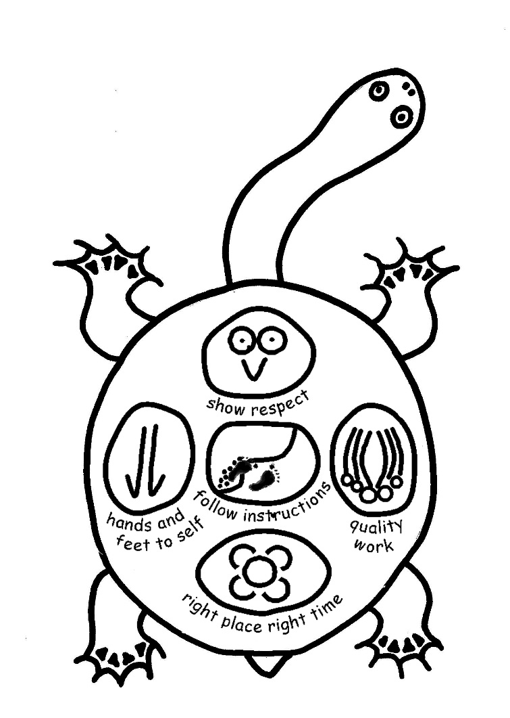

**GOLD**

**Privileges:**

**\* Reward Afternoon (Twice a term)**

**OPAL**

**Privileges:**

**\* Opal Reward Day (Excursion)**

**\* Prize Draw – Local Voucher**

**SILVER**

**Privileges:**

**\* Reward afternoon (Twice a term)**

**BRONZE**

**Privilege:**

**\* Reward afternoon (Twice a term)**

**POTCH**

**All students start here**

sch_logo

*At Lightning Ridge Central School we create positive, safe and respectful learning environments that engage students in quality lessons,*

*celebrate success and promote lifelong learning*

**Monitoring Card**

Name: \_\_\_\_\_\_\_\_\_\_\_\_\_\_\_\_\_\_\_\_\_

Goals

1.\_\_\_\_\_\_\_\_\_\_\_\_\_\_\_\_\_\_\_\_\_\_\_\_\_\_\_\_\_\_\_\_\_\_\_\_\_\_\_\_\_\_\_

2.\_\_\_\_\_\_\_\_\_\_\_\_\_\_\_\_\_\_\_\_\_\_\_\_\_\_\_\_\_\_\_\_\_\_\_\_\_\_\_\_\_\_\_

**Collect:** Roll Call

**Drop off:** Front office

Supervisor:\_\_\_\_\_\_\_\_\_\_\_\_\_\_\_

|  |  |  |  |  |  |  |
| --- | --- | --- | --- | --- | --- | --- |
|  | **ROLL CALL** | **P 1** | **P 2** | **P 3** | **P 4** | **P 5** |
| **Subject** |  |  |  |  |  |  |
| ***Right Place Right Time*** |  |  |  |  |  |  |
| ***Following Instructions*** |  |  |  |  |  |  |
| ***Work***  ***Complete*** |  |  |  |  |  |  |
| ***Show Respect*** |  |  |  |  |  |  |
| ***Hands and Feet to Self*** |  |  |  |  |  |  |
| **Teacher Sign** |  |  |  |  |  |  |

(√= Yes / X = No)

Comments

P1: \_\_\_\_\_\_\_\_\_\_\_\_\_\_\_\_\_\_\_\_\_\_\_\_\_\_\_\_\_\_\_\_\_\_\_\_\_\_\_\_\_\_\_\_\_\_\_\_\_\_\_\_\_\_\_\_\_\_

P2: \_\_\_\_\_\_\_\_\_\_\_\_\_\_\_\_\_\_\_\_\_\_\_\_\_\_\_\_\_\_\_\_\_\_\_\_\_\_\_\_\_\_\_\_\_\_\_\_\_\_\_\_\_\_\_\_\_\_

P3: \_\_\_\_\_\_\_\_\_\_\_\_\_\_\_\_\_\_\_\_\_\_\_\_\_\_\_\_\_\_\_\_\_\_\_\_\_\_\_\_\_\_\_\_\_\_\_\_\_\_\_\_\_\_\_\_\_\_

P4: \_\_\_\_\_\_\_\_\_\_\_\_\_\_\_\_\_\_\_\_\_\_\_\_\_\_\_\_\_\_\_\_\_\_\_\_\_\_\_\_\_\_\_\_\_\_\_\_\_\_\_\_\_\_\_\_\_\_

P5: \_\_\_\_\_\_\_\_\_\_\_\_\_\_\_\_\_\_\_\_\_\_\_\_\_\_\_\_\_\_\_\_\_\_\_\_\_\_\_\_\_\_\_\_\_\_\_\_\_\_\_\_\_\_\_\_\_\_

Executive PBL Guidance Playground Beautification

Teacher \_\_\_\_\_\_\_\_\_\_\_\_\_\_\_ Teacher \_\_\_\_\_\_\_\_\_\_\_\_\_\_\_

Parent Sign Supervisor Sign

\_\_\_\_\_\_\_\_\_\_\_\_\_\_\_ \_\_\_\_\_\_\_\_\_\_\_\_\_\_\_

**Behaviour Code for Students**

NSW public schools are committed to providing safe, supportive and responsive learning environments for everyone. We teach and model the behaviours we value in our students.

***In NSW public schools students are expected to:***

* Respect other students, their teachers and school staff and community members.
* Follow school and class rules and follow the directions of their teachers.
* Strive for the highest standards in learning.
* Respect all members of the school community and show courtesy to all students, teachers and community members.
* Resolve conflict respectfully, calmly and fairly.
* Comply with the school's uniform policy or dress code.
* Attend school every day (unless legally excused).
* Respect all property.
* Not be violent or bring weapons, illegal drugs, alcohol or tobacco into our schools.
* Not bully, harass, intimidate or discriminate against anyone in our schools.
* Schools take strong action in response to behaviour that is detrimental to self or others or to the achievement of high quality teaching and learning.

***Behaviour Code for Students: Actions***

Promoting the learning, wellbeing and safety of all students in NSW Public Schools is a high priority for the Department of Education and Communities.

We implement teaching and learning approaches to support the development of skills needed by students to meet our high standards for respectful, safe and engaged behaviour.

***Respect***

* Treat one another with dignity.
* Speak and behave courteously.
* Cooperate with others.
* Develop positive and respectful relationships and think about the effect on relationships before acting.
* Value the interests, ability and culture of others.
* Dress appropriately by complying with the school uniform or dress code.
* Take care with property.

***Safety***

* Model and follow departmental, school and/or class codes of behaviour and conduct.
* Negotiate and resolve conflict with empathy.
* Take personal responsibility for behaviour and actions.
* Care for self and others.
* Avoid dangerous behaviour and encourage others to avoid dangerous behaviour.

***Engagement***

* Attend school every day (unless legally excused).
* Arrive at school and class on time.
* Be prepared for every lesson.
* Actively participate in learning.
* Aspire and strive to achieve the highest standards of learning.

The principal and school staff, using their professional judgment, are best placed to maintain discipline and provide safe, supportive and responsive learning environments. The department provides a policy framework and resources such as Legal Issues Bulletins, access to specialist advice, and professional learning to guide principals and their staff in exercising their professional judgment. In this context the NSW Government and the Department of Education and Communities will back the authority and judgment of principals and school staff at the local level.